**Vocabulary Words:**

**Molecular Geometry:** The three-dimensional arrangement (bond lengths and bond angles) of the atoms that constitute a molecule.

**Angular Wavenumber (k):** The spatial frequency of a wave with units of inverse length. It is interpreted as the number of waves (one cycle) per unit distance.

**Exercise:** Listed below are a few common software packages used within the XAS community. Some specialize in particular theoretical calculations and others in data processing and analysis. For each software give a brief description (1 to 2 lines) of what it is used for.

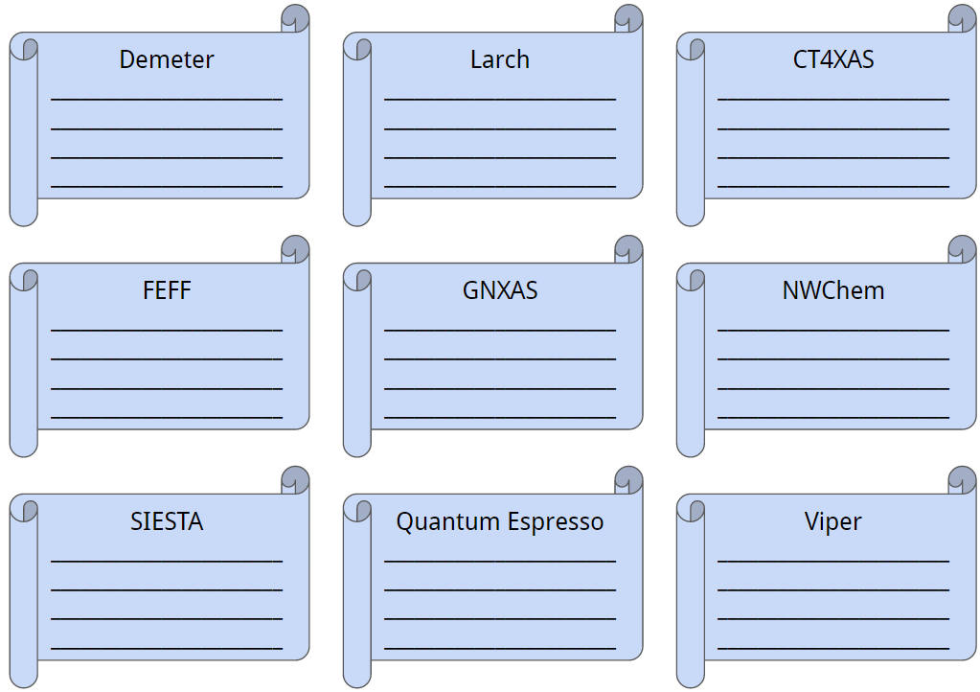

**Exercise:** Ellie the electron has just been excited out of an atomic bound state and into a continuum state. Help her find her way out of the material before she loses too much energy to inelastic collisions!

